**CSCE 470**

**Programming Assignment #2**

**Jason Gilman**

**10-18-2020**

**Introduction**

This report will describe the design and results for three text classification algorithms: Naïve-Bayes, KNN, and Rocchio. Finally, explainations for time complexity will be given for each algorithm.

**Results**

Naïve-Bayes - Full set   
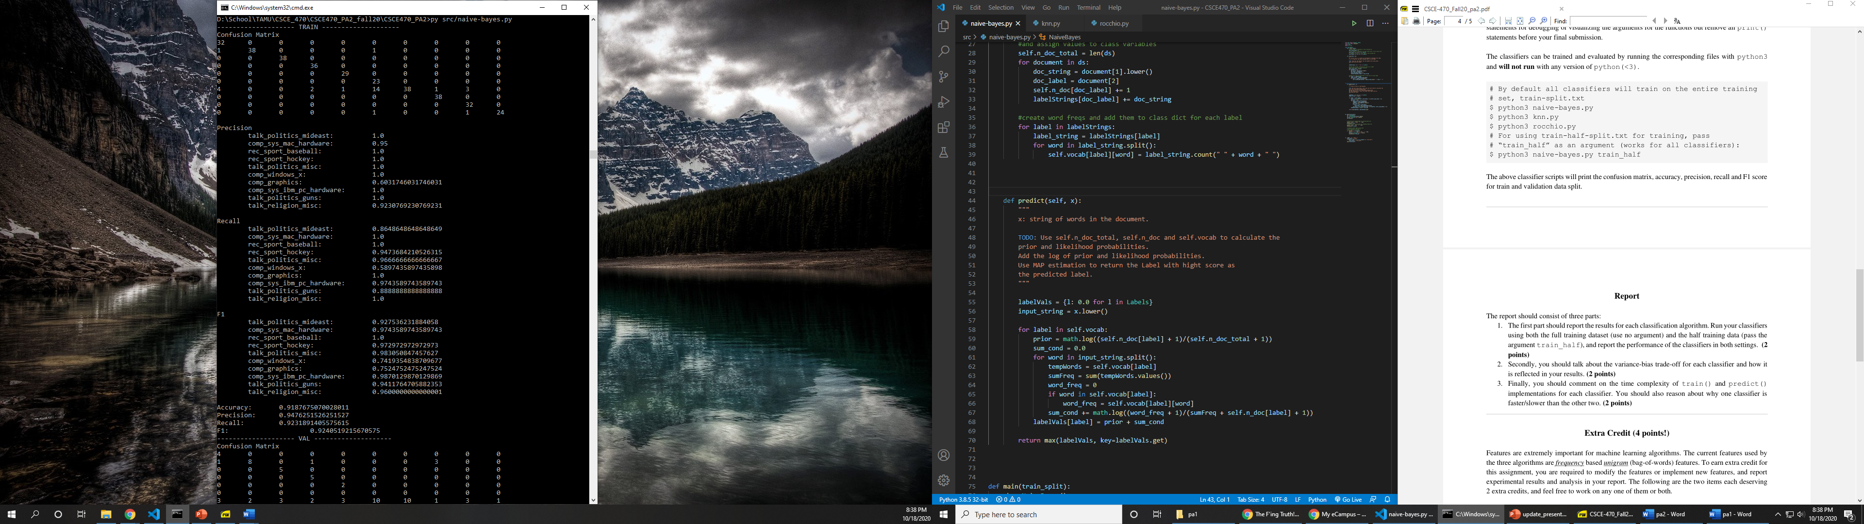

Naïve-Bayes – Full Set

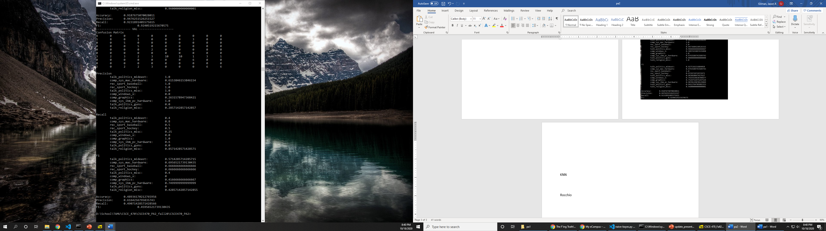

Naïve-Bayes – Half Set

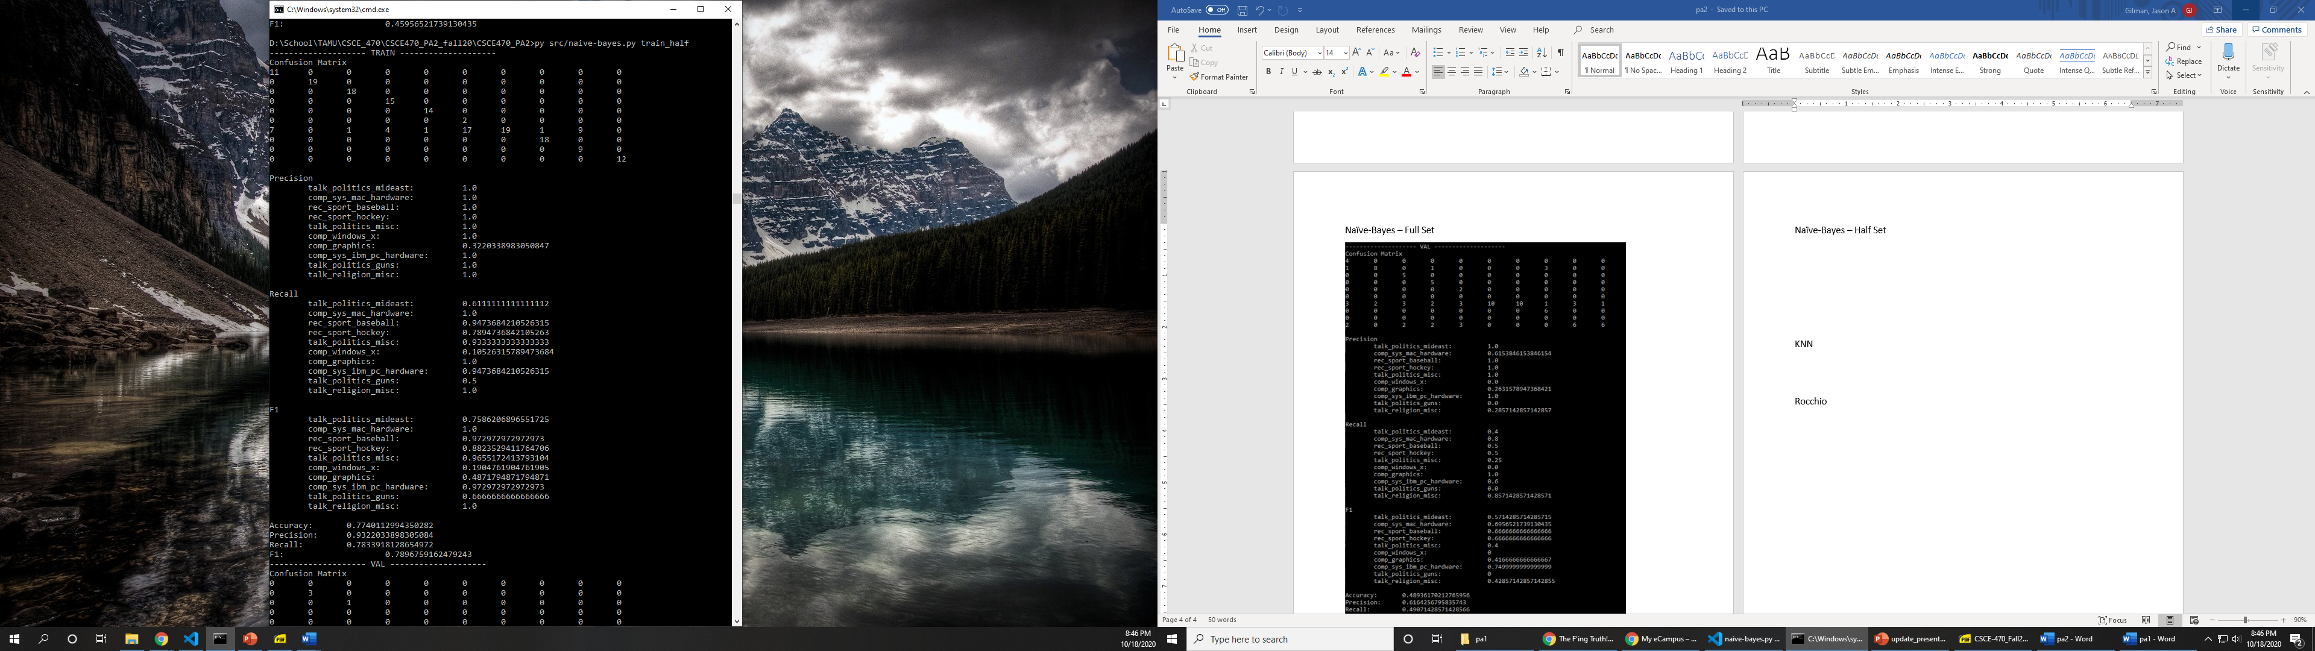

Naïve-Bayes – Half Set

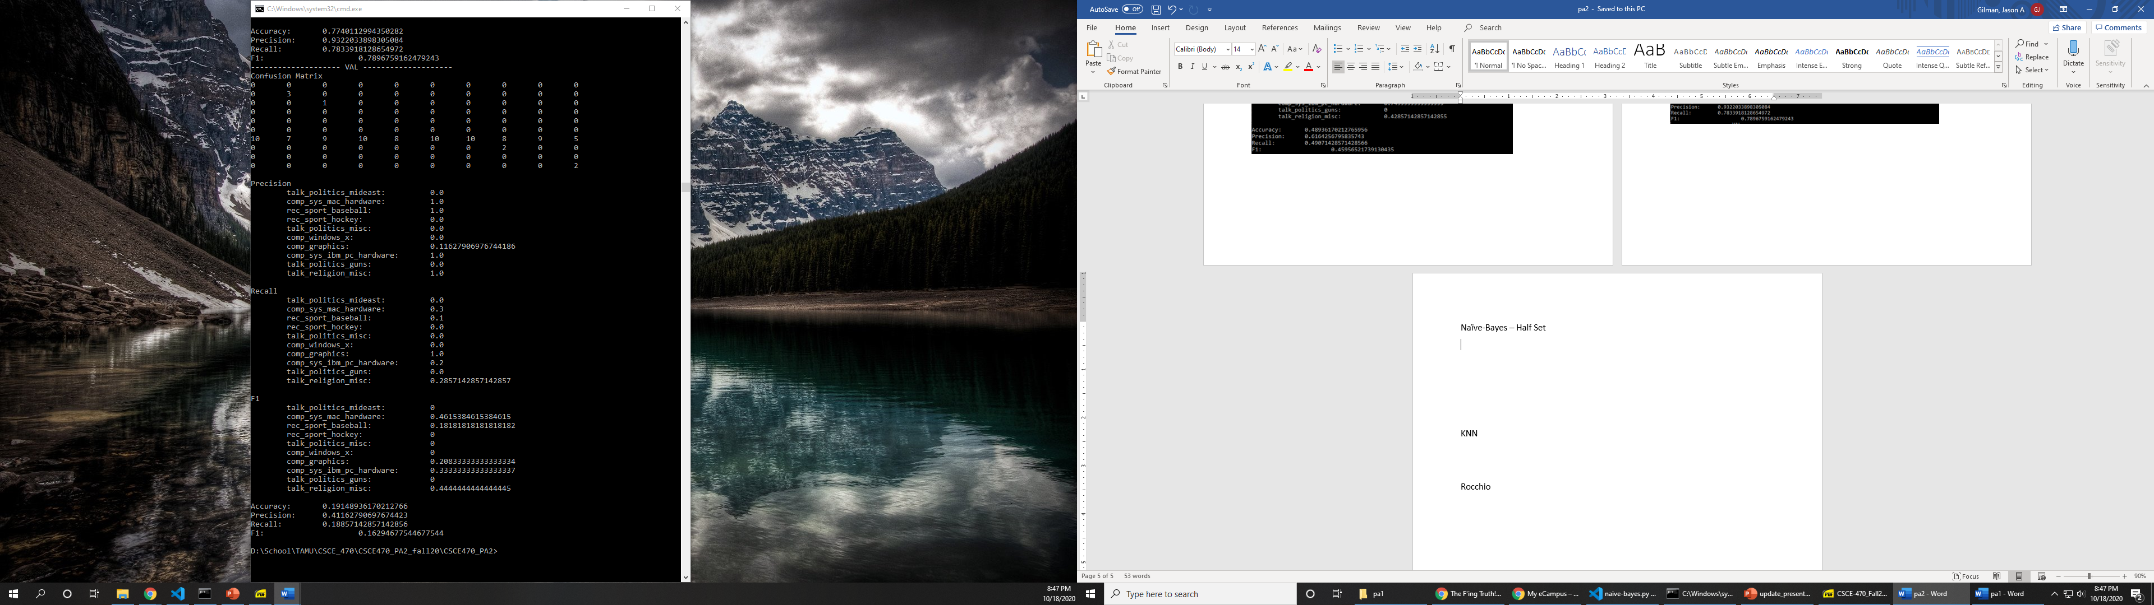

KNN – Full Set

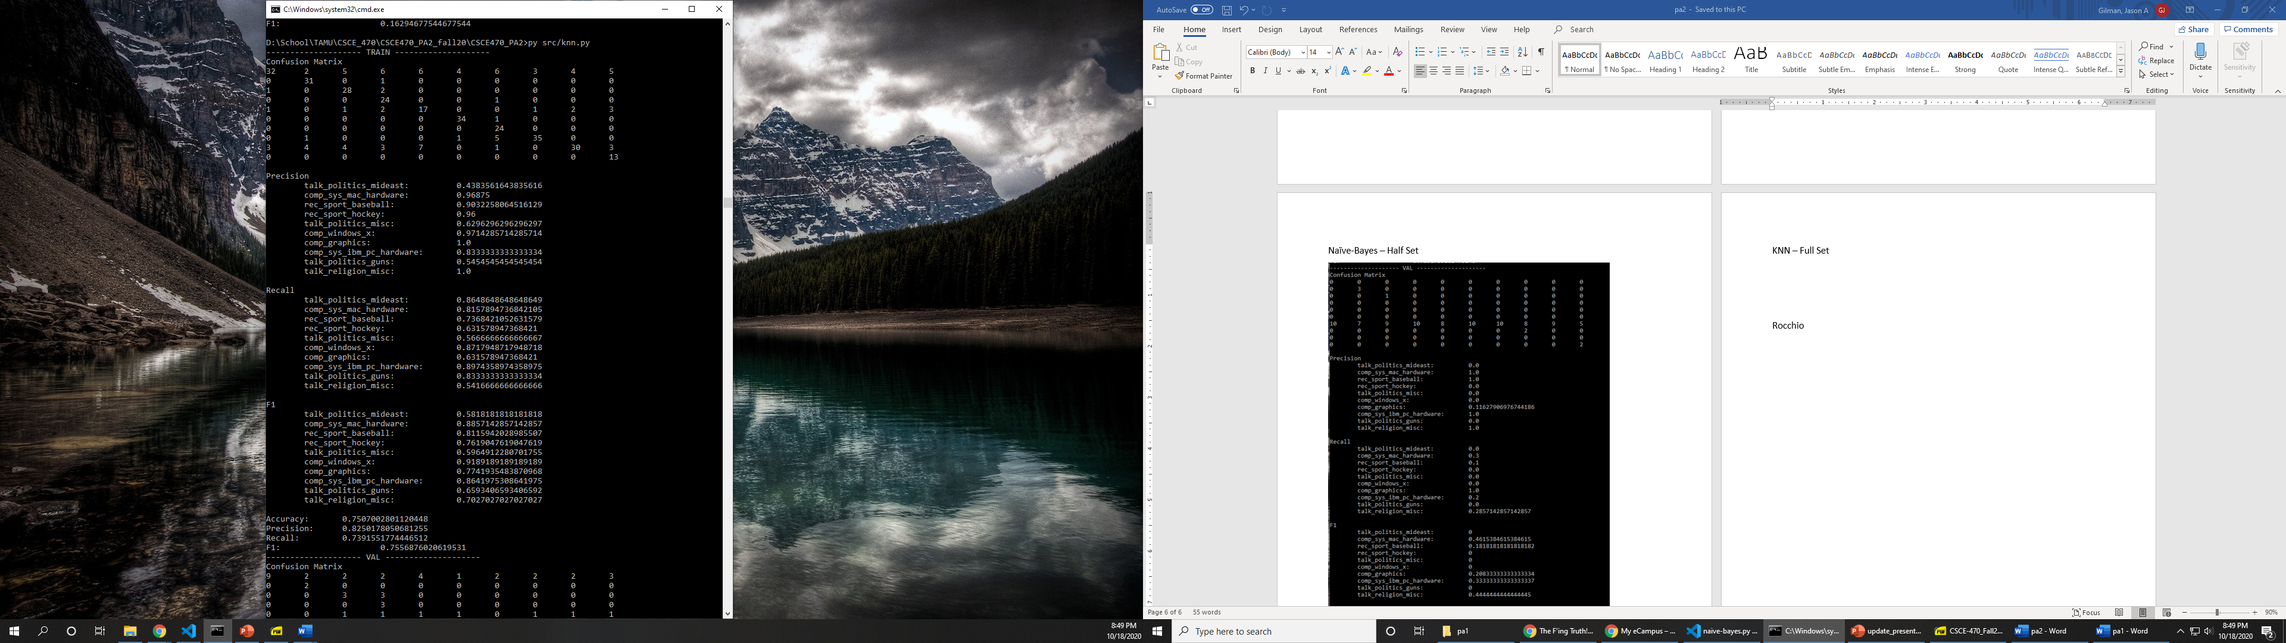

KNN – Full Set

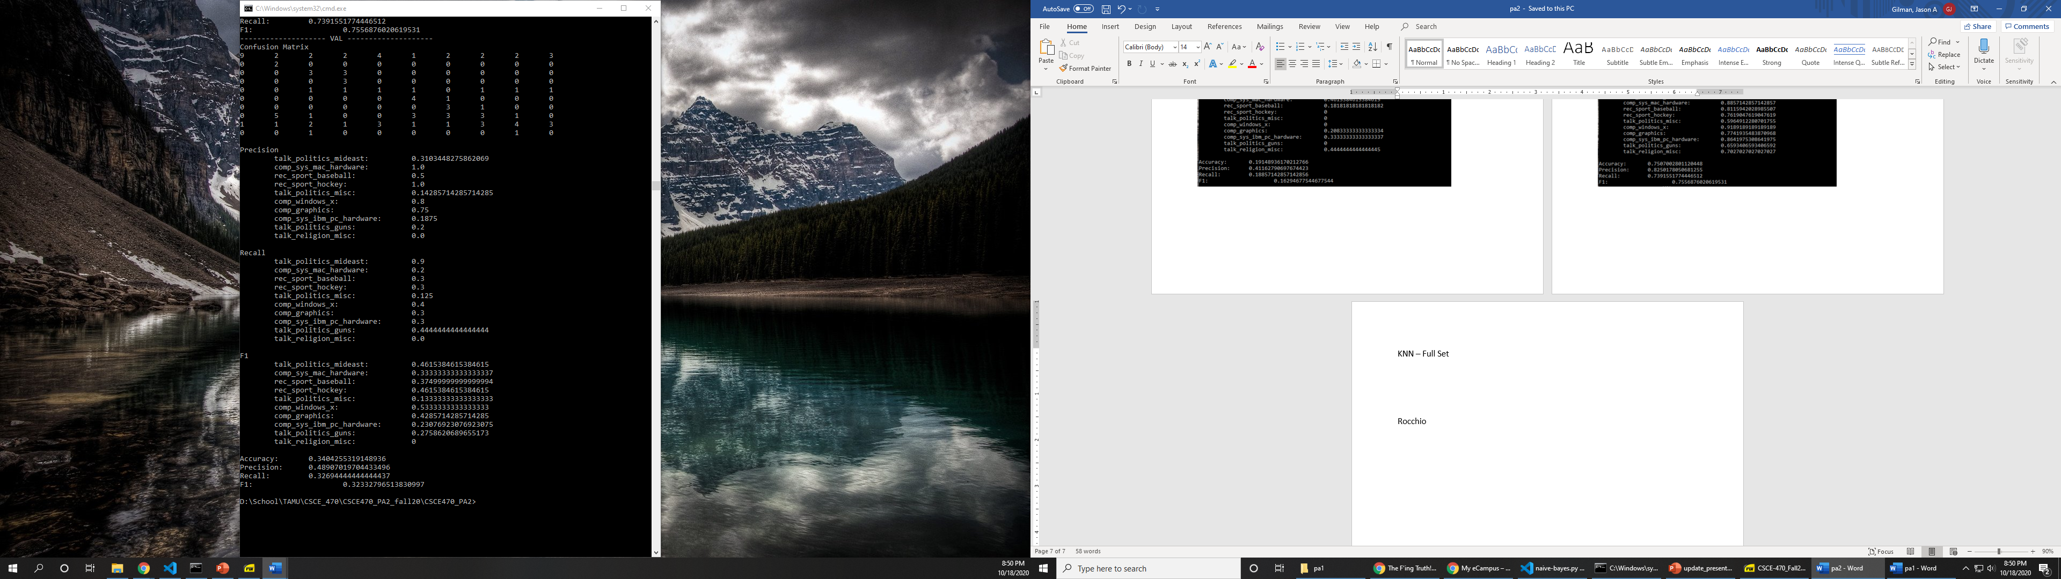

KNN – Half Set

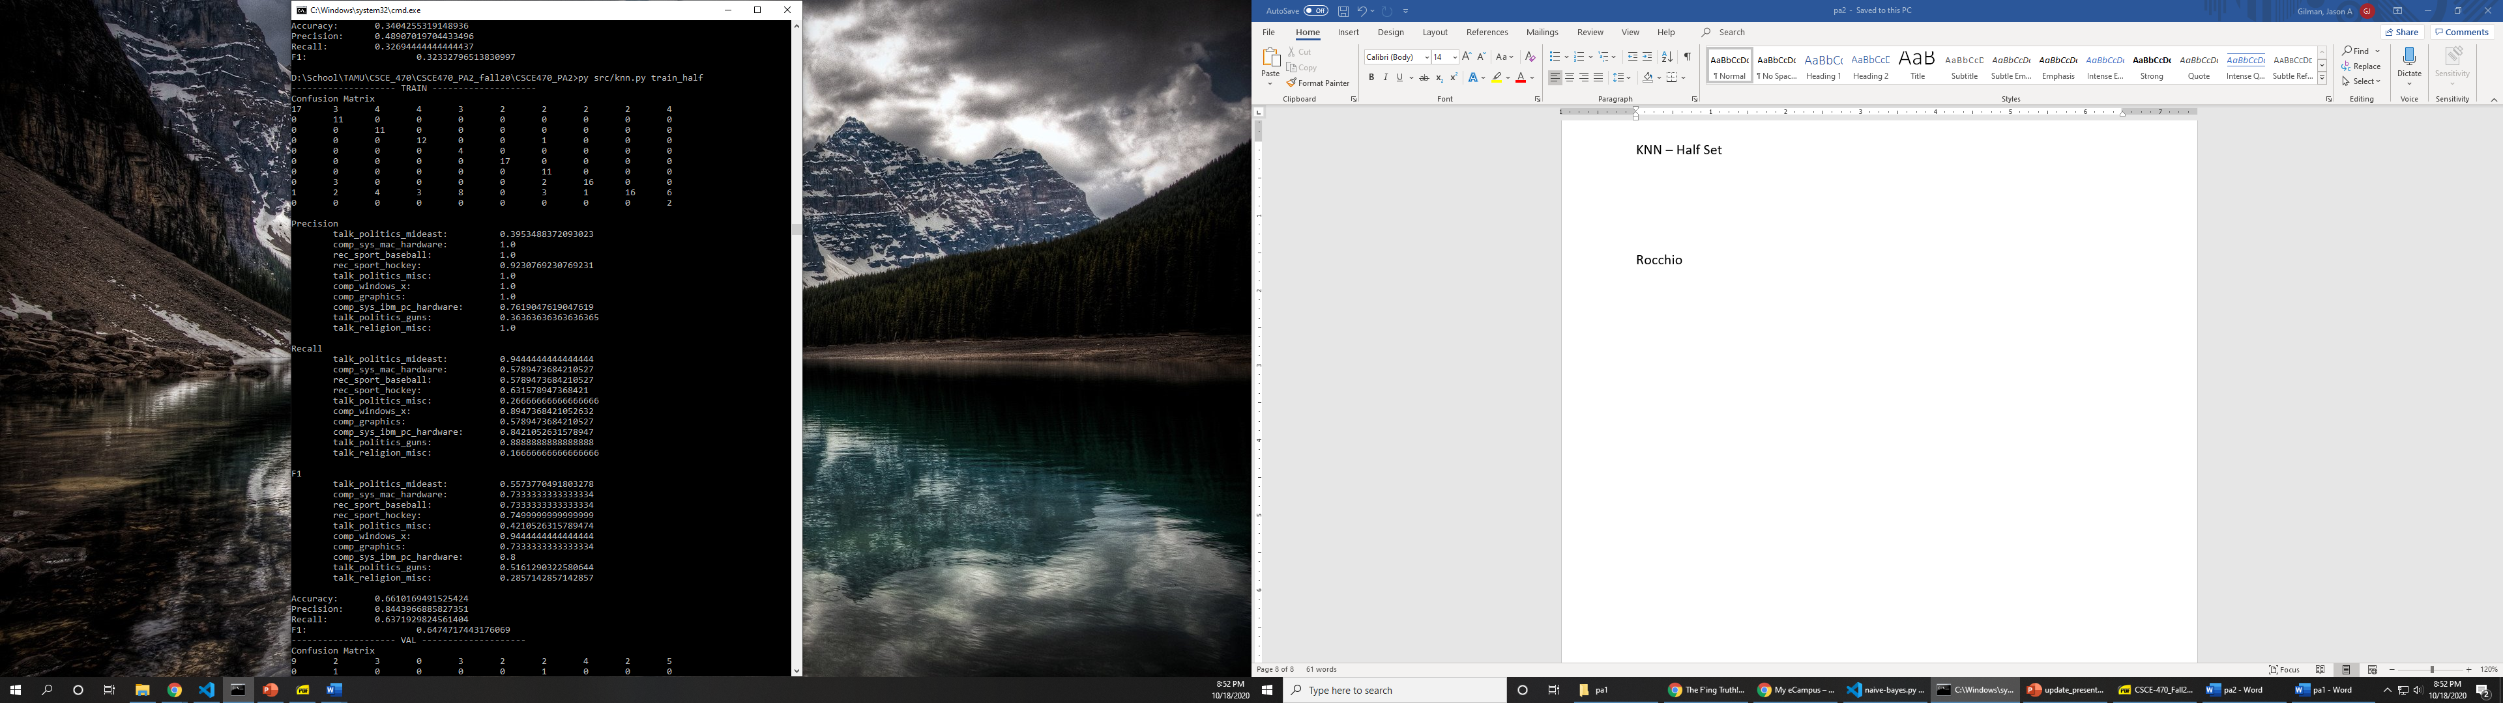

KNN – Half Set

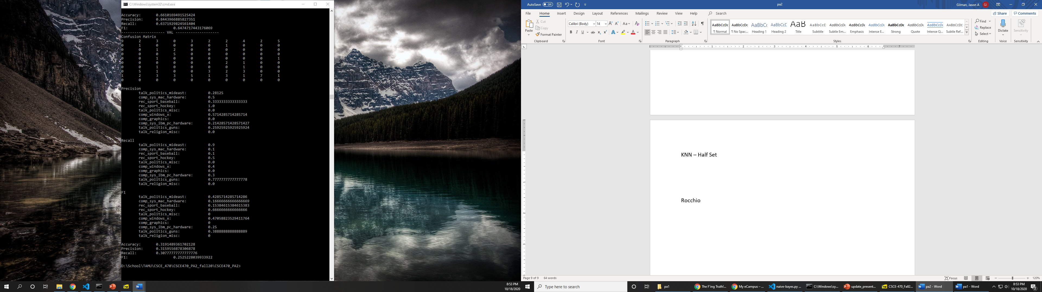

Rocchio – Full Set

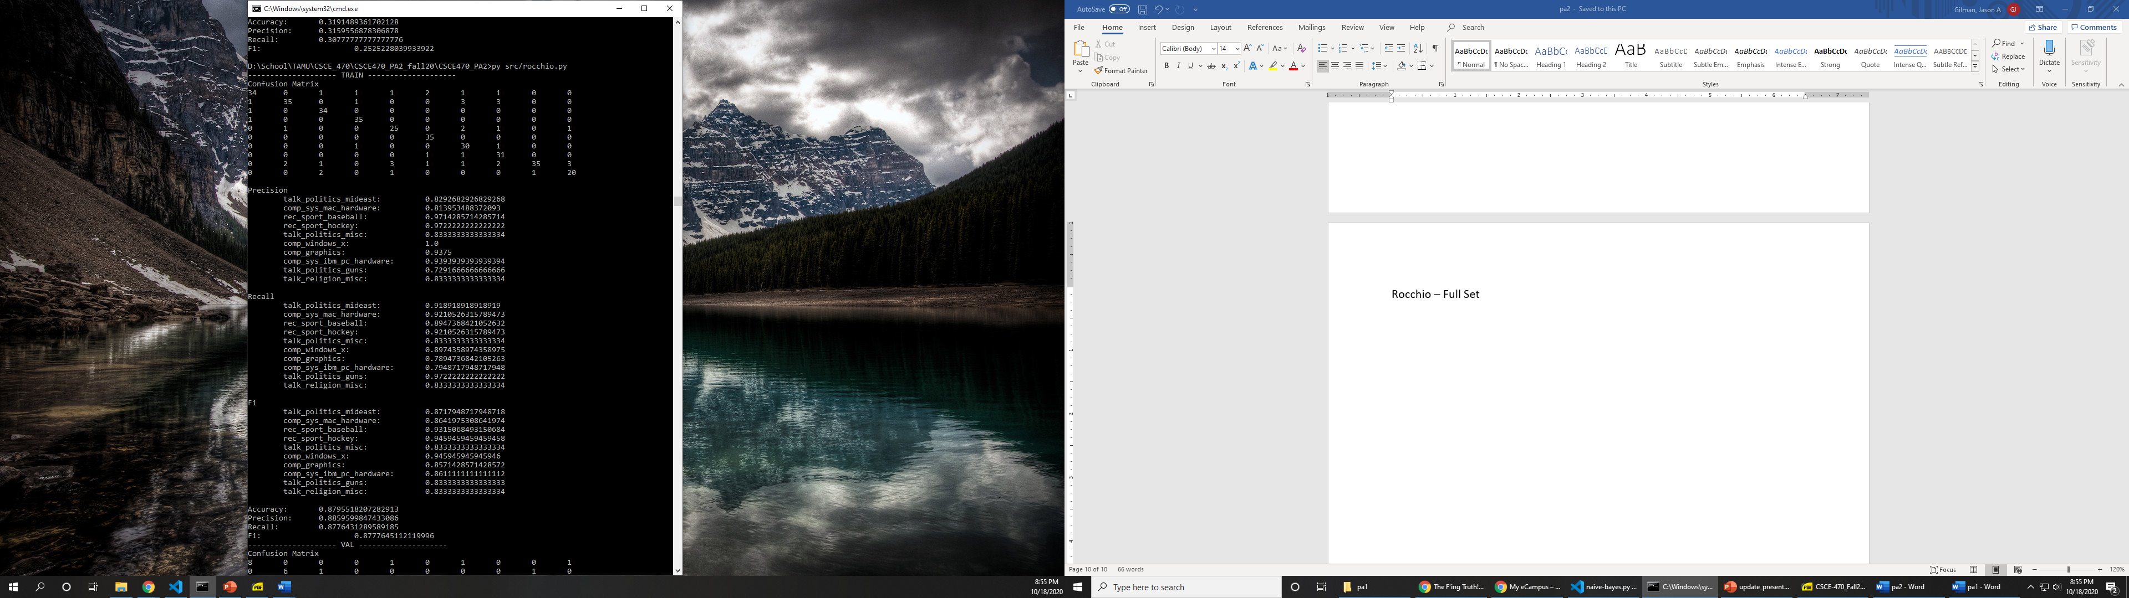

Rocchio – Full Set

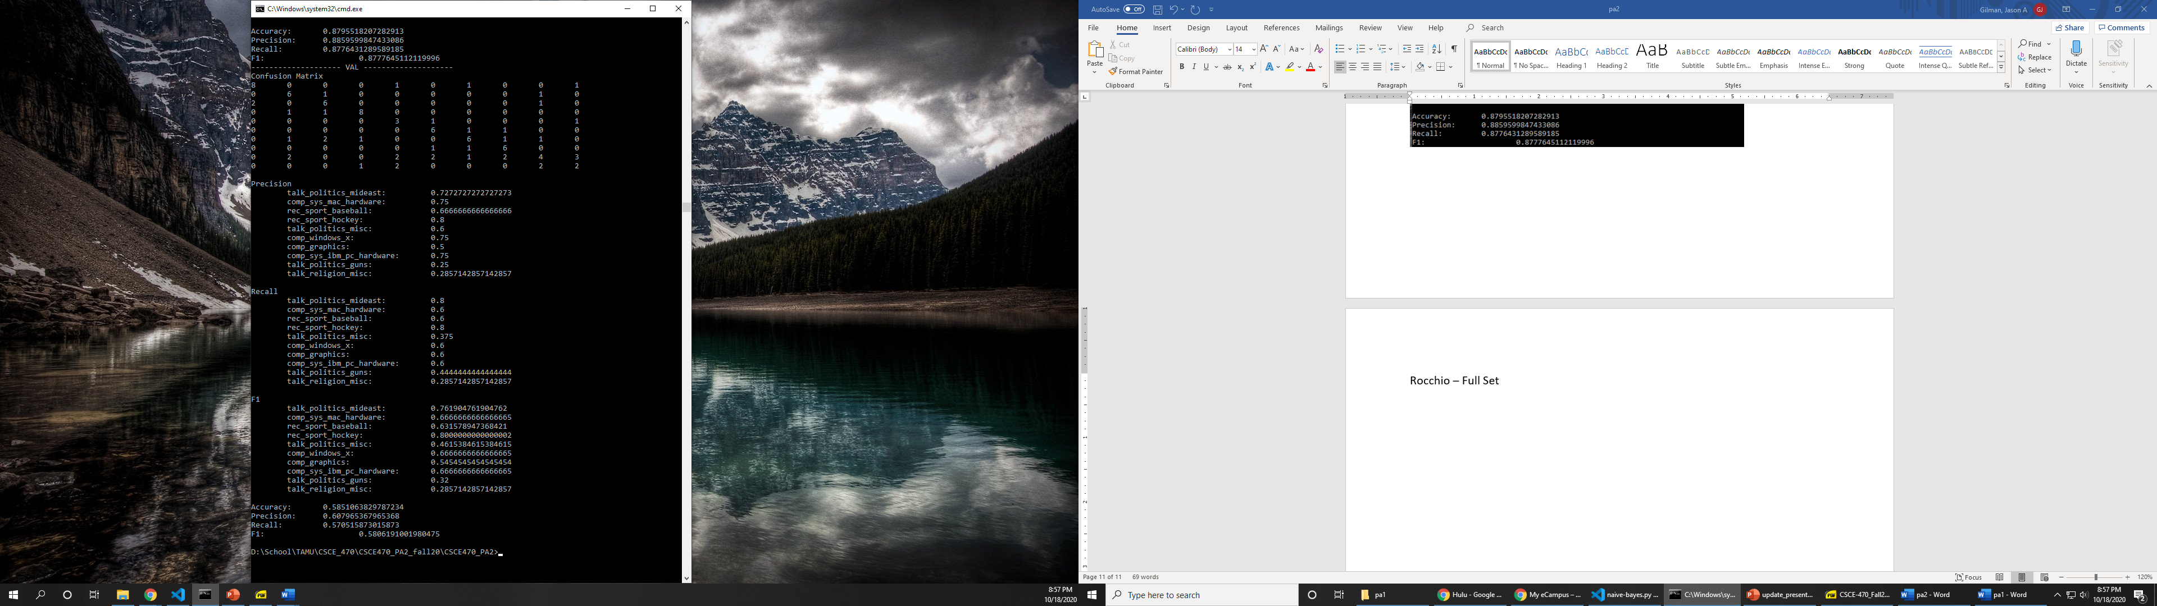

Rocchio – Half Set

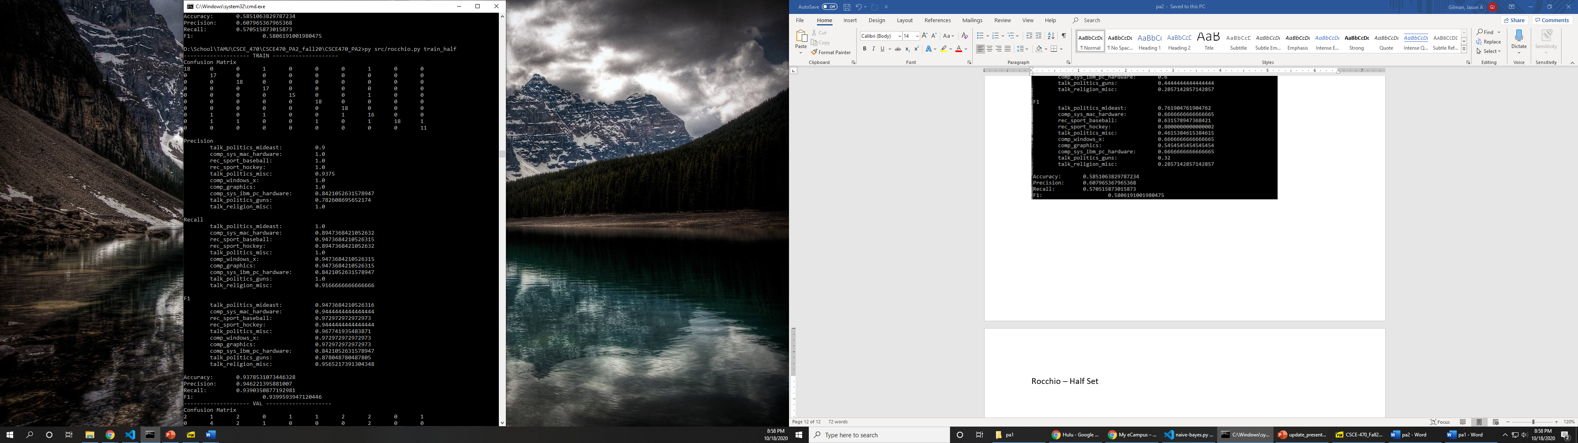

Rocchio – Half Set

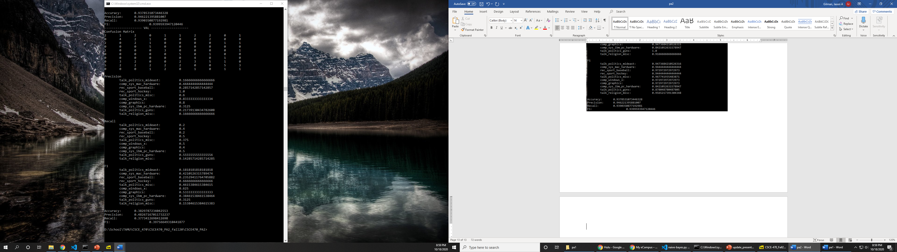

**Variance-Bias**

Naïve-Bayes

This model was designed so that it considered only a few featueres, which provided a highly biased solution. Only term frequency was considered in the model, while laplace smoothing was used to make the predictions more uniform. To have a higher variance, more features would need to be considered, or increased weight could be given to certain docuemtns. The linearity of the naïve-bayes model also adds to its high bias. The difference in classes is more defined because of the classifiying of the documents. From the output statistics, a high bias is shown by the proportion between accuracy and precsision, where precsion is favored.

KNN

This model was designed using a single parameter, the K value which determined the number of neighboring documents to consider in the final prediction analysis. For my model I chose a high K value, 5. While having a higher K value offers greater bias in predictions, the KNN model still has a high variance due to its non-linearity. The difference in classes due to where each document is classified is a non-linear relationship. The normaliztion process aided to add some variance as is weighted the term frequecies. From the output statistics, a high variance is shown by the proportion between accuracy and precision, where accuracy is favored.

Rocchio

This model has high bias as it predicts based on linearly plotted vectors for each document. The boundary for a class is well defined because of the centriod which is based on a class’s documents. When calculating the similarity for the prediction document, you want find the most similar centriod vector. The normaliztion process aided to add some variance as is weighted the term frequecies. From the output statistics, a high bias is shown by the proportion between accuracy and precsision, where precsion is favored.

**Time Complexity**

|  |  |  |  |
| --- | --- | --- | --- |
|  | T_START | T_END | T_TOTAL |
| Naïve-Bayes |  |  |  |
| train() | 1603078348 | 1603078355 | 6.38783002 |
| predict() | 1603078355 | 1603078383 | 27.88059 |
|  |  |  |  |
| KNN |  |  |  |
| train() | 1603078622 | 1603078623 | 0.68500996 |
| predict() | 1603078623 | 1603078632 | 8.74106002 |
|  |  |  |  |
| Rocchio |  |  |  |
| train() | 1603078723 | 1603078723 | 0.71581006 |
| predict() | 1603078723 | 1603078727 | 3.52181983 |

The Naïve-Bayes classifier is slower compared to the KNN and Rocchio classifiers when used on this data set. This is because the Naïve-Bayes classifier compares each document with the prediction document. The other two classifiers have less comparision to the prediction document because the KNN computes the cosine similarity, and the Rocchio computes the cosine similarity between the prediction document and the centriod vector for each class. If the data set size was much greater, it is possible that the Naïve-Bayes classifier would be the faster algorithm.